**Specification document – LockedMe.com;   
  
Author: Lukasz Blicharz  
Version: 0.1**

**Intro & Goal**   
  
Company Lockers Pvt. Ltd. aim to digitize their products and chose LockedMe.com. Goal is to develop a prototype of the application. The prototype of the application will be then presented to the relevant stakeholders for the budget approval.

**Who’s it for?**

Prototype of the application for the customer.

**Why build it?**

Digitize the products of the company Lockers Pvt. Ltd.

**Core Concepts/Technology:**   
  
Developed in the Java language. Implemented the concepts such as exceptions, collections, and sorting techniques for source code optimization and to increased performance. Used Scanner object to allow user to input data and give a choice option for user. Implementation of separate methods to handle single feature separately. Used switch/case to define user inputs and as well as a error handling solution implementation of try/catch and exceptions approach. To make sure that application will be handling exception properly applied do/while loops to allow user have multiple options of selections of next actions avoiding applications to crash due to unknown reasons.

**Time needed to develop:**  
2 sprints -> 4 weeks -> 20 working days

**Features of application planned and delivered:**

|  |  |
| --- | --- |
| Planning items + Features | Time needed to develop |
| Definitions of solution building development plan | 1 day |
| Documentation preparation including flows/charts | 2 days |
| Setting up coding environment along with github account to build repository | 1 day |
| Definitions of features and representing them as tasks bellow | 1 day |
| Display the welcome screen (Application name, developer details) | 0.5 day |
| The details of the user interface such as options displaying the user interaction information | 0.5 day |
| Features to accept the user input to select one of the options listed | 1 day |
| First option to return the current file names in ascending order.  The root directory contains few files already in it. | 2 days |
| The second option should return the details of the user interface such as options displaying the following:   * add a file to the existing directory list. Ignoring the case sensitivity of the file names * delete a user specified file from the existing directory list (implement case sensitivity on the file name to ensure that the right file is deleted from the directory list) return a message if FNF (File not found) * search a user specified file from the main directory (implement case sensitivity on the file name to retrieve the correct file | 4 days |
| Display the result upon successful operation | 0.5 day |
| Display the result upon unsuccessful operation | 0.5 day |
| Option to navigate back to the main context | 0.5 day |
| Option to close the application | 0.5 day |
| Testing activities | 3 days |
| Final review update documentation and upload final version of code on github | 1 day |
| Presentation for Final User | 1 day |

**Application Flow:**  
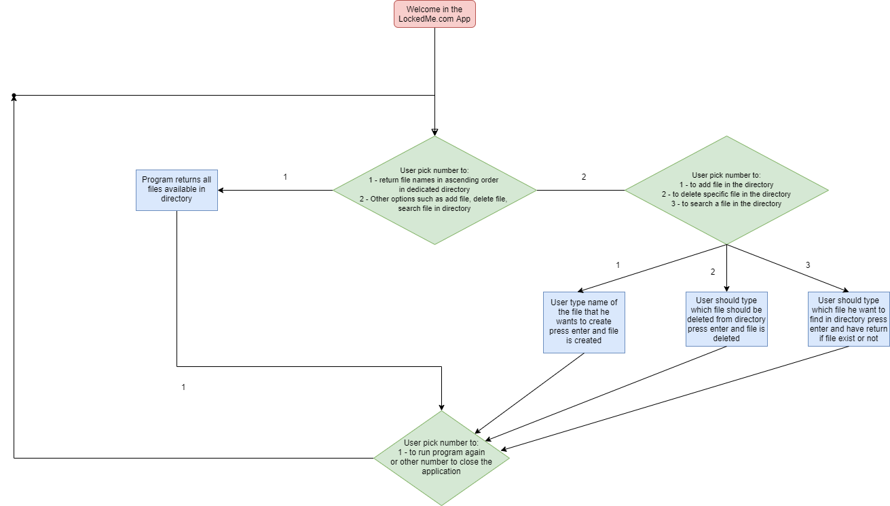

**Source Code – GitHub:**[**https://github.com/MasterBLINNN/SL_ProjectPhase1**](https://github.com/MasterBLINNN/SL_ProjectPhase1)

**Unique Selling Points:**

I designed the product that allow you save a lot of time to enjoy other things than thinking how to handle your files by yourself.   
Developed solutions = Time saving.   
Time is money now you have more time to make more money.